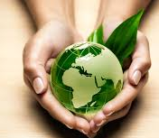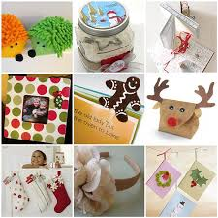
Greening your Holidays

During the holiday season faith and family are easily overwhelmed by commercialism and over consumption. It is easy to fall prey to the message of more is better.
This time year can be an opportunity to create some new traditions that simplify the holiday season into a more meaningful and environmentally responsible experience. Think about and decide what you and your family truly want to get out of the holidays. What memories do you want to give your children? What traditions do you want to begin? What tasks create stress? How can you make it all simpler? Talk to your family and explain what you are trying to do. Share your ideas with friends and family. Ask yourself do I really need to buy this, do I really need to do this?

Here is of some greener gifts:
-Give someone the gift of time by taking on a chore around the house
-Give the gift of your talents by teaching a new skill
-Give an activity by taking them somewhere fun
-Give a homemade gift
-Give a donation
-Give less stuff
-Give products made in an environmentally responsible way

Here are some family activities to try
-Visit a nature center, museum or park
-Take a walk in the woods or on the beach
-Become involved on a community service project
-Give a gift to the environment by changing something in your house to make it greener
-Make a project of sorting through and giving away toys, clothes and other products around the house that are no longer being used.

Even if you do not make wholesale changes, even if all you do use less wrapping paper you are taking step in the right direction.

http://www.vanderbilt.edu/sustainvu/resources/greening-guides/sustainable-holiday-greening-guide/

http://www.becomingminimalist.com/why-fewer-toys-will-actually-benefit-your-kids/

