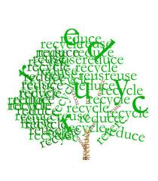
Reduce, Recycle and Reuse Paper

Here are some more ideas for creating a more sustainable household. Of course recycling paper is an important step in living a more sustainable lifestyle, but it is not the only one. To complete the cycle we need to also use and purchase recycled paper. Buying recycled paper helps to create a market for the used paper. Recycled paper is just as good as paper made from virgin materials. It works just as well in printers and copiers. It is easily available. While the cost may be slightly higher, it is a small price to pay for doing the right thing. You will have the most impact if you buy the paper with the highest percentage of post-consumer recycled content. When we conserve paper we are doing more than reducing the number of trees that are cut down we are also conserving water, soil, using less chemicals, fuel, and preserving habitats
Besides using recycled paper there are other actions we can take to use less paper. Here are some questions to ask yourself:
Do I really need to use this paper?
Can I double side my copies?
Is there a way to use email?
Can I use scrap paper instead of a new sheet of paper?
Can I use half a sheet instead of a whole sheet?
What can I do at my place of business to reduce our paper consumption?
http://wwf.panda.org/how_you_can_help/live_green/fsc/save_paper/office_paper/

