Local Literacy 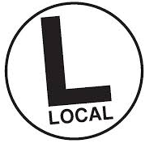

We protect what we love and to protect we need to understand. It is critical we know where we live, understand the place in which we live. This knowlege helps us make the right decision for our home ground. How much do you know about where you live?
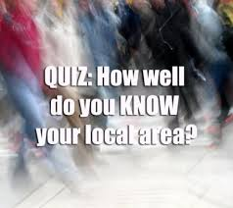
Describe the climate not the weather
What watershed do you live in?
What are ten native plants and animals?
Describe the soil.
What is the closest wild area to your home?
Where does your water come from?
Who lived in your backyard 1000 years ago
Where does your garbage go?
Which way is North from where you are now?
What crops were grown in your area?
What are the most pressing environmental problems in your area?
How does the local geography affect your neighborhood?
What geological events helped to create the landscape to your area?
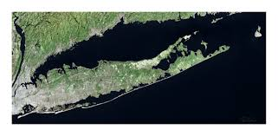

http://longislandnature.org/

