Greener Cars

What does benzene, cadmium, carbon dioxide, carbon monoxide, nitrogen oxides, particulates and sulfur dioxide have in common? They are all coming out of our cars every time we drive. These chemicals have a direct effect on our personal health and health of the planet. Driving a car has the largest negative impact on the environment of anything else we do. The EPA estimates that air toxins from vehicles account for half of all cancers attributed to outdoor sources of air pollution.
Since it is unlikely any of us are going to give up our cars completely there are still some things we can do.

Drive less.
-Combine errands into fewer trips
-Have your child take the bus to school. The bus is coming to Friends Academy anyway and the more children on the bus the less pollution and congestion
-Arrange a carpool for drop off and pick up
-Public transportation really does make a difference
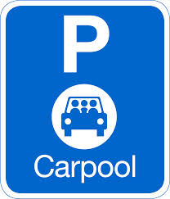

Drive Better
-Do not idle: Ten seconds of idling uses more fuel then restarting your car.
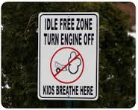
-Drive smooth: Sudden starts and stops decrease your gas mileage.
-Don’t speed, it is safer and uses less gas. Does it really matter if you get where you are going a few minutes faster?
-Regular tune-ups, clean air filters and spark plugs will help make your car engine run smoothly.
-Take the junk out of your trunk: Less stuff in your car makes your car lighter therefore using less gas.
-Inflate your tires: Keeping you tires inflated saves a huge amount of gas. If every --American drove their cars with properly inflated tires it would save 2 billion gallons of gas a year.

http://www.nrdc.org/greengate/guides/driving.asp
.

