Combatting Ecophobia

With all the news of climate change, toxic chemicals, air pollution and other environmental problems children and adults can suffer from ecophobia, a term coined by writer, David Sobel. Ecophobia is the fear created by a focus on only environmental problems. Fear shuts children down and separates them from the wonder of the natural world. Instead of love for the earth there is the overwhelming feeling that nothing can be done. Especially for young children the focus should be creating a relationship with the natural world. Before we ask children to solve environmental problems we must give them the opportunity and support to find their connection to the earth. However children spend less time than ever playing and exploring in the outdoors. A lack of time and places to go children limits their interactions with the natural world.
We need to give children the time, place and freedom to play in nature. Here are some ideas to get you started:
- Turn off the screens and make you children go outside.
- Give them the chance to be bored as the first step in being creative
- Take walk with your children in a nature preserve
- Set up a bird feeder, a place to dig holes, look under rocks, and get dirty
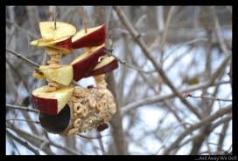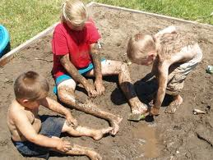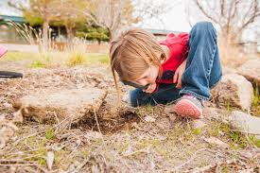
- Let them make a secret place in the yard to hide out and get away
- Leave even a little of the yard wild and undisturbed
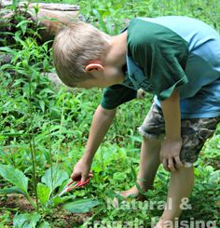
The most important action you can take to help the planet is to raise children that will live the testimony of stewardship. To live a life that speaks this testimony one must love the earth. Children learn to love not by fear but by connections.

http://www.nwf.org/be-out-there/why-be-out-there/health-benefits.aspx

